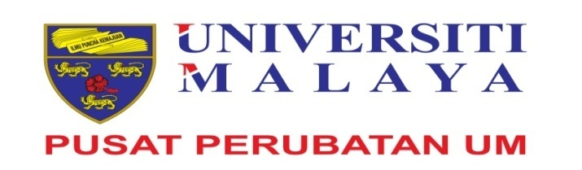

Application is open to Government / Semi-Government and Private Organisation to enroll in the following program :

Program | : | - ADVANCED DIPLOMA IN EMERGENCY NURSING  - ADVANCED DIPLOMA IN CRITICAL CARE NURSING  - ADVANCED DIPLOMA IN PERIOPERATIVE NURSING
Program Duration | : | 1 Year (Full Time)
Date of Program | : | 20 February 2017 - 18 February 2018
Program Venue | : | College of Health Sciences, University Malaya Medical Centre, Kuala Lumpur.
Requirements | : | - Possess Certificate / Diploma or Bachelor in Nursing from a recognised institution.  - Registered with the Nursing Board Malaysia.  - Possess current Annual Practicing Certificate (APC).  - Minimum of two (2) years clinical working experience.  - Possess three (3) months experience in the related specialty.  - Confirmed in the current post (for staff of University Malaya Medical Centre).
Closing Date Permohonan | : | 9 January 2017
How to apply | : | Application form can be downloaded from : www.ummc.edu.my
 |  | Applicants can submit their applications to Principal, College of Health Sciences, 2nd Floor, Wisma R&D, University Malaya, 59200 Jalan Pantai Bharu, Kuala Lumpur with RM10.00 postal order payable to “Pusat Perubatan Universiti Malaya” for processing fee.
Program Fee  (per candidate) | : | RM 8,000.00  RM 9,000.00  RM 16,000.00 | - Government / Semi-Government Agency  - Private Organisation  - International Organisation
ATTENTION | :  : | A complete application must include the following:  - Certified copies of all relevant certificate / diploma / degree which have been indicated in the application form with 2 pasport size photos.  If you do not receive any answer within 1 month from the closing date, please consider your application is unsuccessful.

